[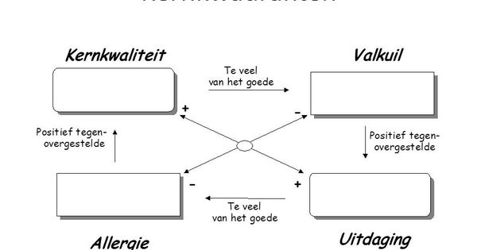](https://www.google.nl/url?sa=i&rct=j&q=&esrc=s&source=images&cd=&cad=rja&uact=8&ved=0ahUKEwix7ci_r77WAhUNZ1AKHe2rBYcQjRwIBw&url=https%3A%2F%2Fwww.pinterest.com%2Fpin%2F319403798544806660%2F&psig=AFQjCNFZj8PHYJ7HMdMOvBUsw_LNsuz6kg&ust=1506361335169695)

[](https://www.google.nl/url?sa=i&rct=j&q=&esrc=s&source=images&cd=&cad=rja&uact=8&ved=0ahUKEwix7ci_r77WAhUNZ1AKHe2rBYcQjRwIBw&url=https://www.pinterest.com/pin/319403798544806660/&psig=AFQjCNFZj8PHYJ7HMdMOvBUsw_LNsuz6kg&ust=1506361335169695)

[](https://www.google.nl/url?sa=i&rct=j&q=&esrc=s&source=images&cd=&cad=rja&uact=8&ved=0ahUKEwix7ci_r77WAhUNZ1AKHe2rBYcQjRwIBw&url=https://www.pinterest.com/pin/319403798544806660/&psig=AFQjCNFZj8PHYJ7HMdMOvBUsw_LNsuz6kg&ust=1506361335169695)